**AMAZON WEB SERVICES:**

What is Cloud Computing?

* **Cloud computing**, storing and accessing data and programs over the Internet.

### Why Cloud Computing?

### Reliability, rising needs of internet capacity, Reduce costs and remove IT obstacles in business.

### Flexibility, data recovery, little or no maintenance, easy access and a higher level of security.

### Advantages of The Cloud Technology

### Cost efficiency

### Elasticity and Flexibility

### Reliability

### Increase Security

### Manageability

### Availability

### Centralization

### Auto-updating

### No maintenance

### Disadvantages of The Cloud Technology

### Internet dependency

### Downtime

### Loss of control

### Lack of support

### Evolution of the Cloud Computing

### Amazon Web Services (AWS), which launched its public cloud in 2002

### In 2006, Amazon launched Amazon Web Service (AWS) on a utility computing basis, Amazon EC2 and Amazon S3

## Cloud Computing Architecture

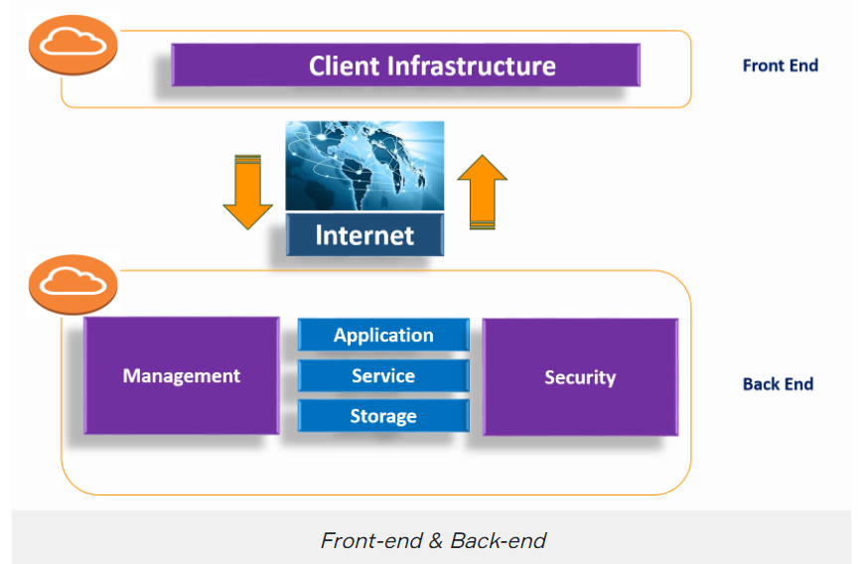

## Cloud Computing Architecture

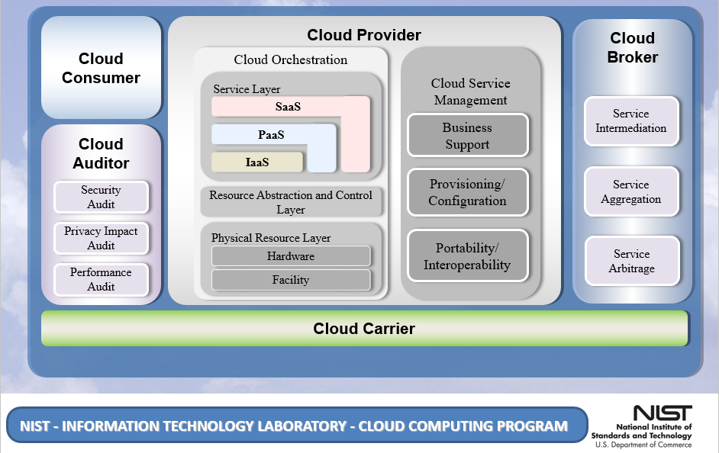

### Cloud Deployment Models

* Public Cloud: Platforms that transfer data to all individuals or organizations with internet access.

**Ex:** Amazon Elastic Compute Cloud (EC2)

### Private Cloud: Provides the same Public Cloud benefits but uses private hardware dedicated to individuals, businesses or groups.

### Community Cloud: A shared platform, usually with shared data and data management considerations, between organizations.

### Hybrid Cloud: Integrated environment of public and private infrastructure.

### Cloud Service Models

### On-Premise: All archives and data are displayed on the server source and not transferred to the internet environment.

### IaaS - Infrastructure as a Service: It's Cloud Computing's most basic service and the instant computing infrastructure which serves, manages, and monitors over the internet.

### PaaS - Platform as a Service: PaaS is a development framework for developers that is designed to create, test, run and manage applications for the programmer.

* SaaS - Software as a Service:A software distribution model in which applications are managed by a third-party provider and made available to customers on the Internet.

### Comparison of Cloud Service Models

### 

### Virtualizations

* Virtualization refers to the operation of multiple operating systems called guest by sharing the same physical equipment resources.
* It allows you to use a physical machine's full capacity by distributing its capabilities among many users or environments.